**Introduction:**

This project is mostly found in warehouses and used for the loading bays. By this circuit the human effort for counting objects, moving objects from one place to another place has been removed and the efficiency and accuracy of the work increases. Overall, the objects coming from bay are placed on the conveyer belt and then these objects are detected by the IR sensor and counted and when this count reached to specific count buzzer gets on and the motor stops and all process again starts when the operator changes the bin.

**Block diagram of the project:**

Start

Bin change

Buzzer On

Motor stop

Start Motor

Check Sensor

If 1

Count=+1

Count>9 count<9

Show 7Seg

If NO

If yes

**Block diagram Explanation:**

Overall the circuit is starting by starting the stepper motor and after that the controller waits for the signal from the IR sensor which sends the pulse when the object is passed in front of the sensor and then the sensor detects it and this is counted by the microcontroller when this count increases from 9 the circuit creates the buzzer to on and motor stops indicating that the bin has full. when the operator changes the bin the operator pushes the button which is the indication that the new bin has arrived.by pressing that the motor stats again and seven segments becomes reset and controller starts counting from 0.

**Circuit diagram:**

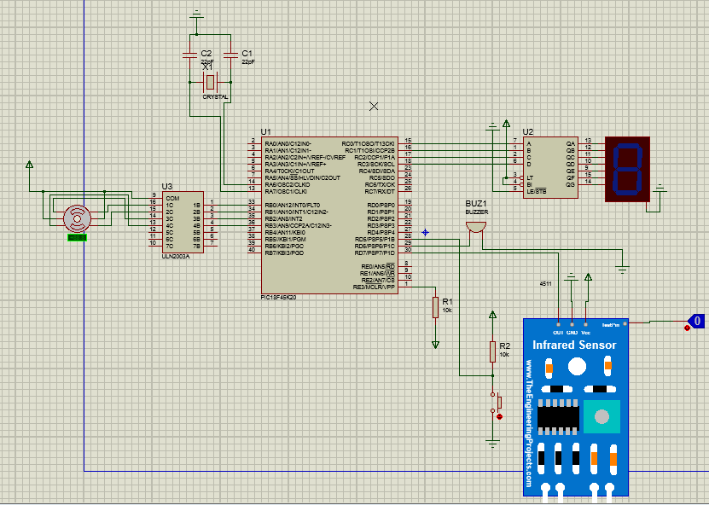

**Circuit diagram Explanation:**

In this circuit the microcontroller which is PIC18F45K20, IR sensor one 4511 which is 7 segment decoder for common cathode display. Apart from these one 7segment is also used to display the current count. Additionally, the stepper uln2003 IC for stepper motor and then in last the stepper motor is also used for the conveyer belt. The crystal oscillator, capacitors, resistors, buzzer and button are also the part of the circuit. The software used for this circuit is Proteus software and simulation is also done on this software.

**Components Used:**

* PIC microcontroller(PIC18f45K20)
* IR Sensor
* Stepper Motor
* Common cathode 7 Segment display
* 4511 7 segment decode
* ULN2003 darlington pair IC
* Buzzer
* Crystal oscillator
* Push button
* Capacitors and resistors

The explanation of these is that:

* **PIC microcontroller(PIC18f45K20):**

This is the heart of the circuit. All the calculations input output and other operations all are done in this controller. It has 5 ports Named as PORTA, PORTB , PORTC, PORTD and PORTE. All the components are attached with these ports and their presence is written in code.

**IR Sensor:**

R sensor is an electronic device, that emits the light in order to sense some object of the surroundings. An [IR sensor](https://robu.in/product-category/sensor/ir-and-pir-sensor/) can measure the heat of an object as well as detects the motion. Usually, in the [**infrared spectrum**](https://en.wikipedia.org/wiki/Infrared_spectroscopy), all the objects radiate some form of thermal radiation. These types of radiations are invisible to our eyes, but infrared sensor can detect these radiations.

The emitter is simply an IR LED [(Light Emitting Diode](https://robu.in/product-category/display-boards/led/)) and the detector is simply an IR photodiode. Photodiode is sensitive to IR light of the same wavelength which is emitted by the IR LED. When IR light falls on the photodiode, the resistances and the output voltages will change in proportion to the magnitude of the IR light received.

There are five basic elements used in a typical infrared detection system: an infrared source, a transmission medium, optical component, infrared detectors or receivers and signal processing. Infrared lasers and Infrared LED’s of specific wavelength used as infrared sources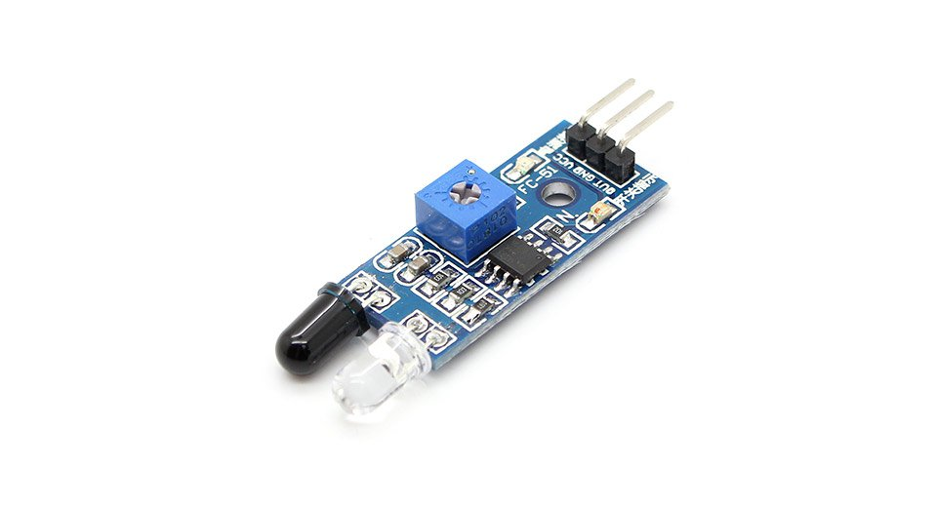

**Stepper Motor:**

A stepper motor is an electromechanical device it converts electrical power into mechanical power. Also, it is a brushless, synchronous electric motor that can divide a full rotation into an expansive number of steps. The motor’s position can be controlled accurately without any feedback mechanism, as long as the motor is carefully sized to the application. Stepper motors are similar to switched [reluctance motors.](https://www.elprocus.com/what-is-a-reluctance-motor-working-its-applications/) The stepper motor uses the theory of operation for magnets to make the motor shaft turn a precise distance when a pulse of electricity is provided. The stator has eight poles, and the rotor has six poles. The rotor will require 24 pulses of electricity to move the 24 steps to make one complete revolution. Another way to say this is that the rotor will move precisely 15° for each pulse of electricity that the motor receives.

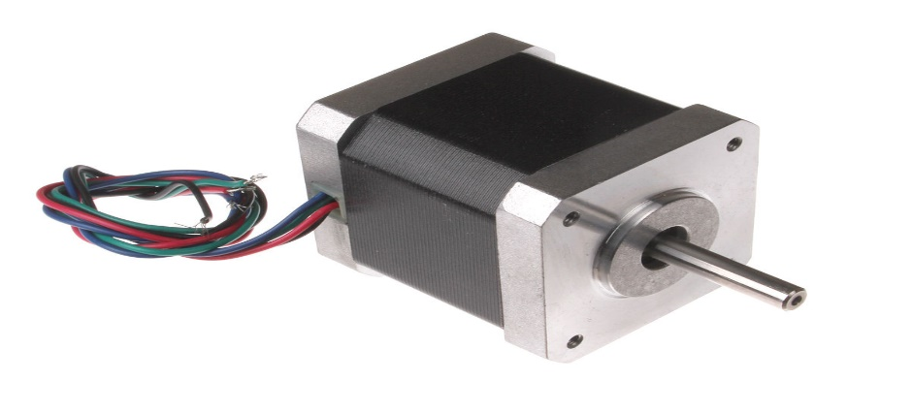

**Seven Segment Decoder:(4511)**

The CD4511 is a BCD to 7-segment decoder. It means it takes a number in binary form as an input, then displays this number on a 7-segment display using its outputs.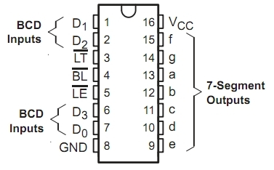

A 7-segment display is a component with seven Light-Emitting Diodes (LED) arranged as shown below. By turning on different combinations of the LEDs, a number between 0 and 9 is displayed.

**ULN2003:**

This is darlington pair IC and it contains transistors and this IC is used to drive the load. The pins from microcontrollers are attached with it and then it drives the stepper motor. The common supply is provided to this IC and the stepper motor.

**Main Parts of Code:**

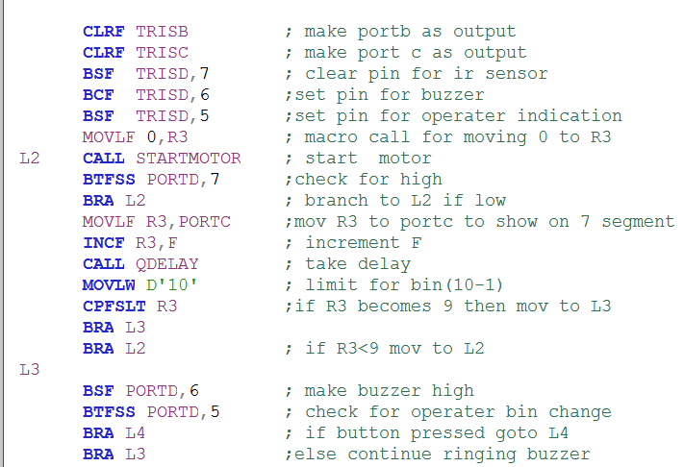

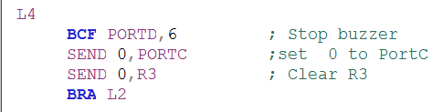

**Code Explanation:**

In start the all the port and pins initialization is done as which pin or port we are going to use as input and which port as output. Then the motor is started by calling start motor subroutine and after that the controller RD7 pin is check again and again as it detects the objects and the t number is displayed on the seven segment and incremented by 1. Similarly this process goes on as the numbers of detected objects become 9 at this time the buzzer starts and motor stops until the user changes the bin and press the button. After pressing button the process again starts from 0 and goes on.

**Results of simulation:**

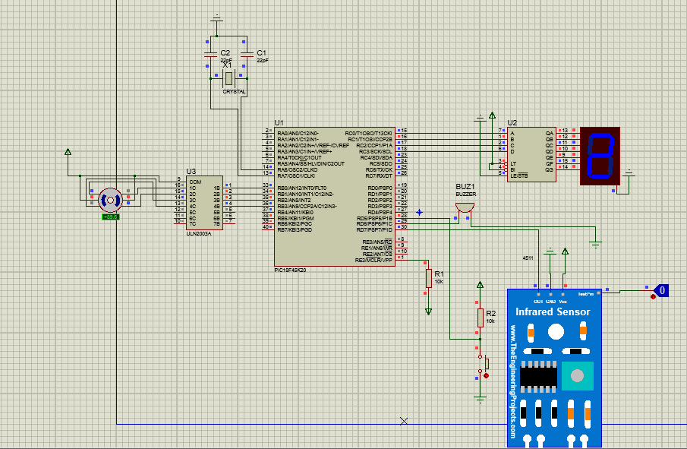

In this fig as a result we can see that the seven segment is showing the numbers and motor is running. This snip is taken from Proteus software.

**Conclusion:**

In this project we have designed the circuit for real world application which is very useful for warehouses and by doing little improvement and implementations we can enhance the capabilities of this project and can use this on industrial and commercial level. Similarly, the bin replacement by human in this project can be replaced by some improvements .